**Analytic Memo 4**

**Jessica Lewis, 10/1 – 10/5**

1. **What data did you collect this week?**

Tuesday 10/2

* Peer Comments #3
* The students were asked to use their peers’ blog responses to help them correct their solutions. Once they had corrected their problem they were instructed to post a reply that re-explains their solution.
* We had a group discussion revisiting the difference between explaining and justifying their answer.
* I completed the **Teacher Observation Form** for each student.

Thursday 10/4

* Discussion Post #4
* Since the students had a test on Friday, I assigned each student a topic from the unit to explain in a blog post. This goal was supposed to act as a good review for the upcoming test.
* I completed the **Teacher Observation Form** for each student.
* I completed the **Blog Evaluation Form** for Discussion #4.

Friday 10/5

* **Unit Test 1**
* **Mid-Study Survey**

1. **Review the qualitative data that you collected this week. List five to ten words (potential codes) that come to mind as a result of this data.**

This week I am starting to dabble with in the third interation of coding. Here is what I have come up with.

Category 1: Peer Audience increases student awareness of writing quality

* Students ask about spelling
* Students ask for teacher clarification
* Verbally discuss posts with a peer before posting for multiple peers
* Use of peer posts to help them write their post
* Students with strong self-efficacy are impacted less by peer audience
* Students with low self-efficacy are intimidated by peer audience

Category 2: The rigor of the content impacts motivation

* Increased excitement during blog time – due to technology use
* Lack of effort when the work is too challenging
* Increased focus and engagement when they understand what to do
* Students display lack of effort when they have to read peer posts
* Lack of effort when asked to think critically
* Lack of effort when asked to justify thinking

Category 3: Mathematical discourse is the foundation for blogging success

* Students are quiet or off task when they do not understand
* Low literacy skills negatively impacts success on the blog
* Strong literacy skills make it easier to explain thoughts
* Students are strong at explaining ideas
* Students lack skills for justifying solutions
* Peer comments consist of simple comments

I am not sure if this is correct. The table from Saldana (2016) displays simpler “subcategories” of codes. I feel like I am just stating the big ideas. It makes sense to me. But please feel free to give suggestions or advice!

1. **In a table, share the quantitative data that you collected this week. This data should not be individual according to student – but should be presented in the form of averages or percentages. Write a short explanation (one or two sentences) of what you think this data means in terms of your research question (s).**

**Teacher Observation Form -** The numbers below represent the average in each category for 9 students. The total amount of points for each category is 4.

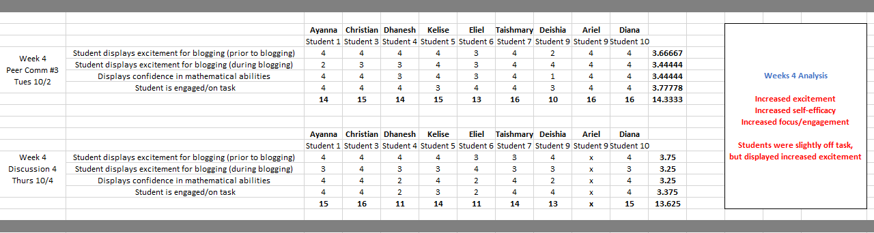

As the study progresses, the students become more and more exciting about the blog each week. They enjoy using the technology during math. Students understand how to access the blog and understand the purpose of writing on a blog. They are displaying more excitement before and during blog use and require less teacher direction each time we have a blog session. This is displayed in their confidence in mathematical abilities and engagement on the task. This instrument is strictly used for observations. Although a student may look confident in their mathematical abilities, this does not directly reflect their mathematical discourse and understanding of the content (this data is displayed in the **Blog Evaluation Rubric**).

**Blog Evaluation Rubric -** The numbers below represent the average in each category for 9 students. The total amount of points for each category is 2.

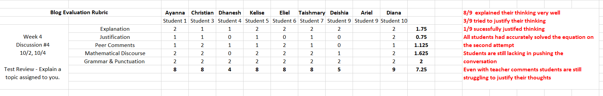

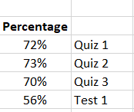**Quiz & Test Scores -** The numbers below represent the average for 9 students

The quiz scores are still stagnant. The students will have their first unit test this week. 4 questions on the unit test ask the students to explain their thinking. This will add dept to their assessment of explanation and justification skills.

The students had their first Unit Test this week. Two of the questions asked them to explain their thinking.

* 7 out of 9 students successfully explained their thinking on the first question.
* 6 out of 9 students successfully explained their thinking on the second question.

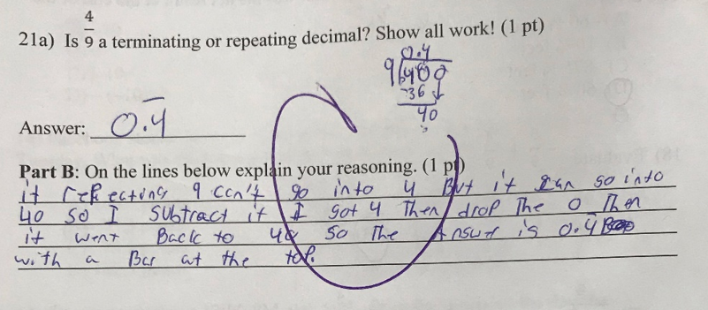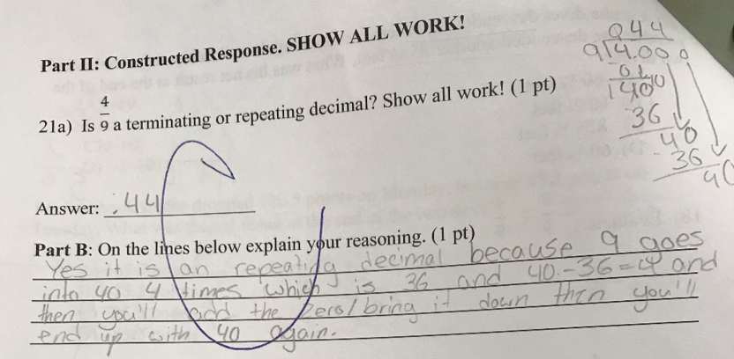Explains and Justifies Explains, tries to justify

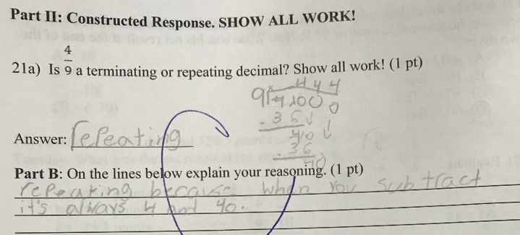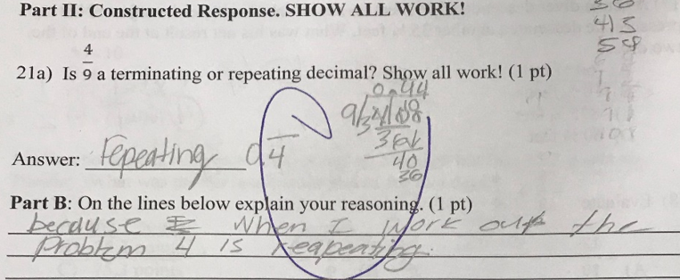

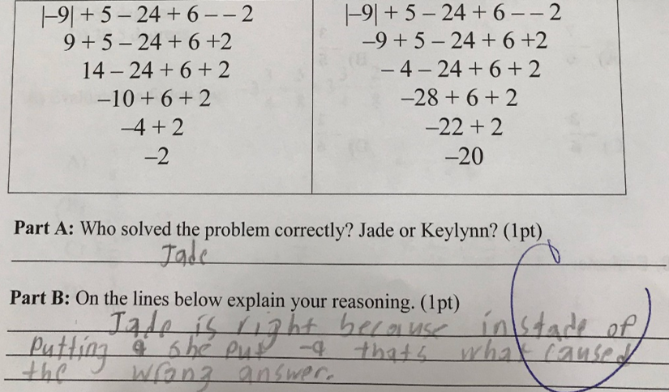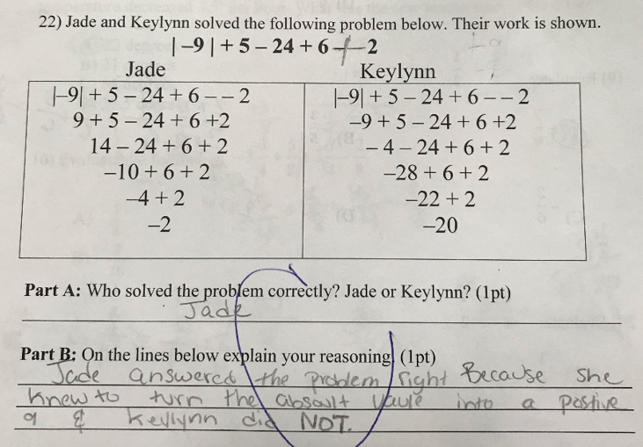Explains and Justifies Explains, does not justify

**Mid-Study Survey**

|  |  |  |  |  |  |
| --- | --- | --- | --- | --- | --- |
| *Pre-Study Survey* | Strongly Agree | Agree | Neither Agree or Disagree | Disagree | Strongly Disagree |
| **I enjoy using the blog during math class** | 33% | 50% | 16% |  |  |
| **The blog helps me understand math better** | 50% | 16% | 33% |  |  |
| **The blog questions are easy for me to answer** |  | 33% | 66% |  |  |
| **I always try to write high quality blog posts** | 16% | 50% | 16% |  | 16% |
| **I enjoy receiving comments from my peers on the blog.** | 66% |  | 33% |  |  |
| **I like writing comments to my peers on the blog.** | 16% | 50% | 33% |  |  |
| **The posts my peers write help me learn** | 50% | 16% | 33% |  |  |
| **The blog is my favorite part of math class.** | 50% | 16% | 33% |  |  |
| **Its easy for me to explain my thinking on the blog.** | 33% | 33% | 33% |  |  |
| **I feel more confident in my mathematical abilities** | 33% | 33% |  | 16% | 16% |
| **Has the blog helped you learn? Explain.** | No i still know the same things as before  yes it did help me a lot.  Yes it did help me learn math problems that i struggled with and my peers as well as my teacher helped me with the problems and broke it up for me. This is how it helped me.  Yes because i had a hard question and i remember that one of the questions where on here.  yes because other people help you understand  yes because i know if i need help someone can explain what idid wrong | | | | |
| **Has reading your peers’ comments helped you learn? Explain** | No i still know the same things as before even with the classmates posts  yes it have reading my peers comment was really helpful.  Yes it did because I struggled with some of my work and they broke it down for me  Yes because i understand what tot do.  yes because they help you  yes because they know how to explain thing great | | | | |

Student responses show that students enjoy writing on the blog and its academic value. Most students find that their peers help them learn.

1. **Write at least one paragraph (it could be more if you like) reflecting on your experience of the week in terms of both student performance and your own practice.**

This week I really tried to push students to justify their thinking. It took a lot of effort to get students to effectively explain their thoughts. Most students can accurately describe a step-by step procedure for how to solve a problem. However, they are still struggling to justify their thoughts. I have modeled a verbal conversation, given them an online example, and had a whole group discussion on what it means to justify their thinking. However, they are just not meeting proficiency yet.

The students are also still struggling to hold back and forth peer conversations. They are not sure how to push the conversation past “simple comments”. When they get confused they usually sit there and wait for me to clarify what to do. So far, the students have been posting about a common subject. To push different conversations, next week I plan to have them research and review a math website or app. Since each post think this will help them write peer comments that push the conversation with questions and/or feedback. This will also support content that is relevant the students’ interests and learning in the classroom.

1. **Write a few sentences (it could be more if you like) outlining the way that this week’s memo is different from last week’s memo.**

This week I have gathered a lot of data. This makes it easier to see patterns and connections within the data. Right now, I am seeing that the students’ motivation to read and comment on the blog increases when they must write their own original posts but decreases when they are challenged to read peer posts and comment with an extending idea. They are also still struggling to justify their thoughts and solutions.

This week’s memo is different from last week’s memo in that I can see their stronger skills and areas for improvement. This allows me to adjust content that focusses on their areas for improvement (justifications skills, peer discussion).

**Field Notes**

**Week 4 (Tues, 10/2) – Peer Comments #3**

* Revisited the difference between Explaining vs Justifying thoughts.
* Had students correct their solutions by reading the posts from their peers. They were directed to leave a reply explaining what they did once they finally got the correct solution.
* Students were surprised when they found out their answers were incorrect (only 2 out of 9 students had the correct answer). strong self-efficacy
* They did not want to use the blog to help them fix their solution because they felt like it took too long. They wanted instant help from the teacher. low literacy
* Motivation and excitement increased once they realized they could get the answer by simply reading some of the explanation from their peers. Multiple perspectives
* Next Time:
  + Review for test
  + Students each assigned one topic to explain on the blog
  + 2-3 peers comments about explanations

**Week 4 (Thurs, 10/4) – Discussion #4**

* Students were reviewing for their first unit test
* Each was assigned a topic to explain and teach to their peers on the blog.
* Many students needed some teacher clarification and were unsure how to explain their topic.
* They became off task when they didn’t understand
* They displayed increased excitement when they were pulled for the blog study
* At the beginning of class, 2 students asked if we would be blogging today.
* Students were slightly discouraged when they were assigned a topic. They wanted to choose their own topic. As a challenge I strategically assigned the topic based on knowledge and writing skills.
* Next Time:
  + Students will pick an online math website or app to review on the blog
  + Students will review each other’s websites in peer comments.